3.3 How Earthquake prediction works

Step 1: Import Required Libraries The notebook imports several Python libraries, including:
● sklearn for machine learning tasks.
● matplotlib.pyplot for data visualization.
● numpy and pandas for data manipulation.
● sklearn_pandas for working with Pandas DataFrames in scikit-learn.
● Various modules from sklearn.preprocessing, sklearn.decomposition, sklearn.linear_model, sklearn.pipeline, and sklearn.metrics for data preprocessing and modeling. It also applies a ggplot style to matplotlib and enables inline plotting.
Step 2: Load Data
● The dataset india_surroundings_1mar2016_28_feb_2017.csv is read using Pandas.
Step 3: Explore the Data
● df.head() is used to display the first few rows of the dataset.
● Some columns (IRIS ID, Year, Month, Day, Time UTC) are deleted from the dataset.
● df.describe() is used to generate summary statistics of the numerical columns.
Step 4: Data Visualization and Correlation Analysis
● pd.scatter_matrix(df, figsize=(12,12), diagonal='kde') creates a scatter matrix plot to visualize relationships between numerical features.
● df.corr() calculates and displays the correlation matrix.
Step 5: Data Preprocessing
● df = pd.get_dummies(df, columns=['Region']) applies one-hot encoding to the Region column, converting categorical values into numerical binary columns.
Step 6: Machine Learning Pipeline Setup
● pipe = sklearn.pipeline.make_pipeline(mapper, sklearn.svm.SVC()) sets up a machine learning pipeline that includes preprocessing (mapper) and a Support Vector Classifier (SVC).

Step 7: Splitting Features & Target
● The feature matrix X is created by making a copy of df and dropping the Mag column (which seems to be the target variable).
● The target variable y is set to df.Mag.
Step 8: Train-Test Split The dataset is split into training and testing sets using: X_train, X_test, y_train, y_test = train_test_split( X, y, test_size=0.33, random_state=42 )
● ○ 33% of the data is used for testing.
Step 9: Train a Support Vector Regression (SVR) Model A Support Vector Regression (SVR) model is initialized and trained using: svm = sklearn.svm.SVR() svm.fit(X_train, y_train)
Step 10: Model Evaluation The model's Mean Squared Error (MSE) is calculated using: mean_squared_error(svm.predict(X_test), y_test)
● The predicted vs actual values are printed: for a, b in zip(svm.predict(X_test), y_test): print(a, b)

3.3.1 Workflow
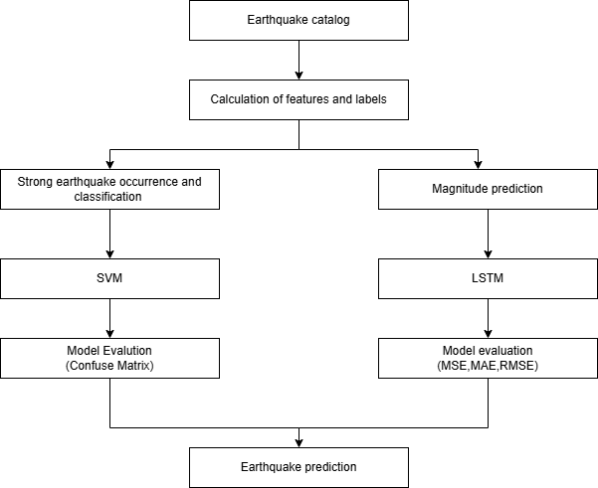

3.3.2 Machine learning model
1. Support Vector Machine (SVM)
✅ What is SVM
● SVM is a supervised learning model used for classification and regression.
● It works by finding a hyperplane that best separates data into classes (in classification) or fits the data points (in regression).
● The goal is to maximize the margin between the closest data points (support vectors) and the hyperplane.
✅ Mathematical Concept For classification:
w⋅x+b=0w \cdot x + b = 0 where:
● ww = weight vector
● xx = input feature vector
● bb = bias term For regression: y=w⋅x+by = w \cdot x + b where the objective is to minimize the error while keeping the margin small.
✅ How SVM Works (Step-by-Step)
1. Map data to a higher-dimensional space using a kernel (like RBF, polynomial).
2. Find the optimal hyperplane using the support vectors.
3. Minimize the error using a cost function (like hinge loss).
✅ When to Use SVM
● When data is linearly or non-linearly separable.
● Effective in high-dimensional spaces.
● Works well for small to medium-sized datasets.
2. Long Short-Term Memory (LSTM)
✅ What is LSTM
● LSTM is a type of Recurrent Neural Network (RNN) used for time-series data and sequence-based problems.
● Unlike traditional RNNs, LSTM solves the vanishing gradient problem using a structure of gates. ✅ Mathematical Concept LSTM cell works with 3 gates:
1. Forget Gate – Decides what information to discard:
ft=σ(Wf⋅[ht−1,xt]+bf)f_t = \sigma(W_f \cdot [h_{t-1}, x_t] + b_f)
2. Input Gate – Decides what new information to store:
it=σ(Wi⋅[ht−1,xt]+bi)i_t = \sigma(W_i \cdot [h_{t-1}, x_t] + b_i)
3. Output Gate – Decides the output:
ot=σ(Wo⋅[ht−1,xt]+bo)o_t = \sigma(W_o \cdot [h_{t-1}, x_t] + b_o)
✅ How LSTM Works (Step-by-Step)
1. LSTM receives input vector + previous hidden state + cell state.
2. The forget gate decides what to discard from memory.
3. The input gate updates the cell state with new information.
4. The output gate produces the final output.
✅ When to Use LSTM
● Time-series forecasting
● Sequential data (e.g., stock prices, language modeling)
● Situations where long-term dependencies are important

